|  |  |
| --- | --- |
|  | wvrap_logo.jpg  **Member Requirements**  **Privileges By Wyndham 2014**  **Business and Functional Requirements Specification**  Version 0.7  17th, March 2015  *Author: Andrew Crawford*  \_\_\_\_\_\_\_\_\_\_\_\_\_\_\_\_\_\_\_\_\_\_\_\_\_\_\_\_\_\_\_\_\_\_\_\_\_\_\_\_\_\_\_\_\_\_\_\_\_\_  "LEGAL NOTICE: This document(s) and the information disclosed herein are the proprietary and confidential data of Wyndham Vacations and Resorts Asia Pacific Pty Ltd.  Neither this document(s) nor the information contained within shall be distributed or reproduced without the express written authorization of Wyndham Vacations and Resorts Asia Pacific Pty Ltd." |

## History

|  |  |  |  |
| --- | --- | --- | --- |
| **Version** | **Date** | **Name** | **Brief Description of Each Change** |
| 0.1 | 20/10/2014 | Andrew Crawford | Initial document creation |
| 0.2 | 21/10/2014 | Andrew Crawford | Made sure the mock-ups showed a \* next to mandatory fields.  Added a validation that we capture a Mobile or Home Phone.  Changed Suburb to Suburb / City  Changed the ‘First Name’ and ‘Last Name’ on Request additional card to ‘Additional First Name’ and ‘Additional Last Name’.  For Request Additional Cards, noted that this shows a history of cards issued. |
| 0.3 | 03/11/2014 | Andrew Crawford | Changes to the Additional Names function after clarification that Owners cannot specify additional names. |
| 0.4 | 02/01/2015 | Andrew Crawford | Noted that the Country value needs to be set from a Dropdown and Webservice |
| 0.5 | 11/02/2015 | Andrew Crawford | Updated the document after discussion on the additional card requests |
| 0.6 | 12/02/2015 | Andrew Crawford | Updated with comments from Ilona. |
| 0.7 | 16/03/2015 | Andrew Crawford | Removed the Terms and Conditions acceptance from the Reset Password page (since this is now handled through the Logon Specification).  Added the ‘Old Password’ field to the Reset Password page.  Incorporated comments from Ilona. |

## Related Documents

|  |  |
| --- | --- |
| **Document** | **Location** |
| Privileges Requirement document | T:\Projects\IT Projects\PBW\Privileges 2014\Requirements\ PBW Requirements Spec 2014 v0.4.docx |
|  |  |

Contents

[1.1 History 2](#_Toc411522409)

[1.1 Related Documents 2](#_Toc411522410)

[2 Update Member Information 4](#_Toc411522411)

[2.1 Page Access 4](#_Toc411522412)

[2.2 Navigation to Page 4](#_Toc411522413)

[2.3 Navigation from Page 4](#_Toc411522414)

[2.4 Screen Wireframes 4](#_Toc411522415)

[2.4.1 Screen Fields 5](#_Toc411522416)

[2.5 Screen Actions 6](#_Toc411522417)

[3 Request Additional Cards 6](#_Toc411522418)

[3.1 Introduction 6](#_Toc411522419)

[3.2 Screen Access 6](#_Toc411522420)

[3.3 Navigation to Page 6](#_Toc411522421)

[3.4 Navigation from Page 7](#_Toc411522422)

[3.5 Screen Wireframes 7](#_Toc411522423)

[3.5.1 Screen Fields 8](#_Toc411522424)

[3.6 Screen Actions 9](#_Toc411522425)

[4 Change Password Page – Owners and Discovery 9](#_Toc411522426)

[5 Change Password Page – Public and Staff 10](#_Toc411522427)

[5.1 Navigation to Page 10](#_Toc411522428)

[5.2 Navigation from Page 10](#_Toc411522429)

[5.3 Screen Wireframes 10](#_Toc411522430)

[5.3.1 Screen Fields 10](#_Toc411522431)

[5.4 Screen Actions 10](#_Toc411522432)

[6 Contact Us Form 11](#_Toc411522433)

[6.1 Page Access 11](#_Toc411522434)

[6.2 Navigation to Page 11](#_Toc411522435)

[6.3 Navigation from Page 11](#_Toc411522436)

[6.4 Screen Wireframes 11](#_Toc411522437)

[6.4.1 Screen Fields 12](#_Toc411522438)

[6.5 Screen Actions 12](#_Toc411522439)

[7 System Messages 14](#_Toc411522440)

# Update Member Information

## Page Access

This page is shown to all user types.

## Navigation to Page

* Shown when the user clicks on ‘Update Information’ from the Navigation menu.

## Navigation from Page

* The user clicks on any link from the Navigation menu

## Screen Wireframes

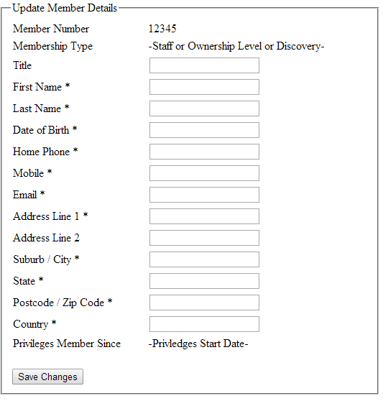

**Note:** This is just a rough guide to required fields and basic layout. It is not intended as a final design

### Screen Fields

|  |  |  |
| --- | --- | --- |
| **Item** | **Type** | **Mandatory** |
| Member Number | Label  Shows the WWID or Privileges Membership Number. |  |
| Membership Type | Label  Shows the current membership type. |  |
| Title | Input Field  20 CHAR | N |
| First Name | Input Field  50 CHAR | Y |
| Last Name | Input Field  50 CHAR | Y |
| Date of Birth | Date Picker  Date format should be: Day (2 Digits) / Month (2 Digits) / Year (4 Digits) | Y |
| Home Phone | Input Field  20 CHAR | N  (Conditional) |
| Mobile | Input Field  20 CHAR | N  (Conditional) |
| Email | Input Field  320 CHAR | Y |
| Address Line 1 | Input Field  100 CHAR | Y |
| Address Line 2 | Input Field  100 CHAR | N |
| Suburb / City | Input Field  50 CHAR | Y |
| State | Drop down – Australian States  Or  Input Field  50 CHAR | Y |
| Postcode  Or  Postcode / Zip Code | Input Field  10 CHAR | Y |
| Country | Drop-down – Defaulted to Australia.  Values are read from the Country Webservice  If they change the country to anything other than Australia, state is changed to an Input Field (100 CHAR).  Postcode label changed to Postcode / Zip Code when country is anything other than Australia. | Y |
| Privileges Member since | Label  Shows the date the Privileges Membership started.  For everyone else, this is the date their account was created. |  |
| Save Changes | Button |  |

**Note:** The details are prefilled from their membership information. The Mandatory flag and checked is used in case the user removes the entry from a Mandatory field.

## Screen Actions

|  |  |
| --- | --- |
| **Condition** | **Action** |
| * User Clicks on Save Changes * Mandatory field is missing or incorrect | * The message UPDATE\_0001 appears as an error with the value ‘$1’ substituted for the missing value. * One message will appear per missing mandatory field, so this message may appear multiple times. |
| * User Clicks on Save Changes * Mandatory fields filled in. * Mobile and Home Phone is not filled in. | * The message UPDATE\_0001 appears as an error with the value ‘$1’ substituted for the value ‘Mobile or Home Phone’. |
| * User Clicks on Save Changes * All mandatory fields are filled in and correct * User type is General Public, Tour-No-Buy, or Employee | * The message UPDATE\_0002 appears on the page as an Information message. |
| * User Clicks on Save Changes * All mandatory fields are filled in and correct * User type is Owner or Discovery | * The message UPDATE\_0003 appears on the page as an Information message. |

# Request Additional Cards

## Introduction

The screen is for both Owners and Non-Owners.

All Privileges members can request additional cards. They can only request them for names against their memberships.

This means for Owners, they can request them for any other names against their Owner Number. Discovery Members can also request them for any other names against their Discovery Member Number.

For Members of the Public and Staff, they can only request them for themselves.

All members get 1 free additional card request every 12 months.

After that time, they need to pay for any additional card requests.

There is no other way to handle a lost of replacement card within the system.

## Navigation to Page

* Shown when the user selects ‘Request Additional Card’ from the My Account navigation menu.

## Navigation from Page

* The user clicks on any link from the Navigation menu

## Screen Wireframes

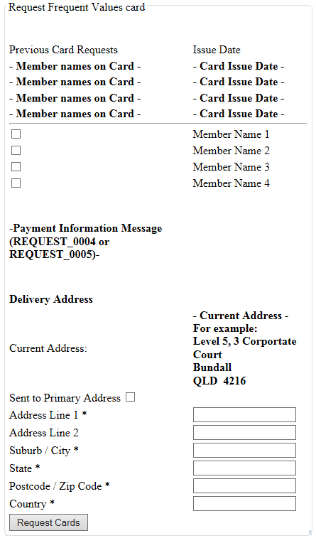

**Note:** This is just a rough guide to required fields and basic layout. It is not intended as a final design.

### Screen Fields

|  |  |  |
| --- | --- | --- |
| **Item** | **Type** | **Mandatory** |
| **- Names on Card -** | Label  This shows all Member names that have had a card request.  This shows the full card request history and card issue history for the last 12 months |  |
| * **- Card Issue Date -** | Label  The date the membership card was issued, in chronological order (oldest to most recent). If this is not an additional card, this is the date the Privileges membership was created. |  |
| * **Payment Information Message -** | If the membership type is OWNER then the content against message REQUEST\_0004 is shown.  If the membership type is PUBLIC, DISCOVERY or STAFF, then the content against message REQUEST\_0005 is shown. |  |
| Member Checkbox | Checkbox  Each member associated with the membership is listed with a checkbox to select sending them an additional card.  Multiple members may be shown against here.  If there is only 1 member name, the checkbox is not shown but the Member Name is still shown. | **Y**  (If Shown) |
| * **Current Address -** | Label  This shows the current address against the membership. |  |
| Sent to Current Address | Checkbox – Checked by default  When unchecked, this shows the address input fields to specify an alternate address to send this to.  This will also show the message REQUEST\_0006 as a label above the address. |  |
| Address Line 1 | Input Field  100 CHAR | Y  (When  Visible) |
| Address Line 2 | Input Field  100 CHAR | N |
| Suburb / City | Input Field  50 CHAR | Y  (When Visible) |
| State | Drop down – Australian States  Or  Input Field  50 CHAR | Y  (When Visible) |
| Postcode  Or  Postcode / Zip Code | Input Field  10 CHAR | Y  (When Visible) |
| Request Cards | Button |  |

## Screen Actions

|  |  |
| --- | --- |
| **Condition** | **Action** |
| * The user checks the ‘Sent to current address’ checkbox. | * The Address fields are hidden |
| * The user unchecks the ‘Sent to current address’ checkbox | * The Address fields are visible. * The message REQUEST\_0006 appears under the checkbox. |
| * User Clicks on Request Card. * Multiple Member Checkboxes are visible. * No names checkboxes are checked | * The message REQUEST\_0001 appears as an error with the value ‘$1’ substituted for the text ‘name’ |
| * 4 or More Member names are shown on the screen. * The user has selected 3 member checkbox names. * The user then selects a 4th member checkbox name. | * The message REQUEST\_0002 appears on the screen as an alert. * The 4th checkbox is not selected. |
| * User clicks on Request Cards * All Mandatory fields are filled in. * The Card Request History service returns that this is the first card request within the 12 months. | * The card request web service is called. * The screen shows message REQUEST\_0003 as an information message. |
| * User clicks on Request Cards * All Mandatory fields are filled in. * The Card Request History service returns that this is not the first card request within the 12 months. | * The user is taken to the external NAB payment gateway page for our account. * They will be charged once for the card request. * The payment gateway service handles updating the record with the receipt number and returning to a success screen. * The screen shows message REQUEST\_0003 as an information message on the success screen shown. |

# Change Password Page – Owners only

# This will show a WCM page (which we will supply the link for) when the Member type is OWNER and they click on the Change Password link. Change Password Page – Public, Staff and Discovery

## Navigation to Page

* Shown when the user selects ‘Change Password’ from the Navigation Options
* This page will not be visible to Owners members.

## Navigation from Page

* A logged in user uses the standard Navigation Options to navigate to another page.
* A non-logged in user clicks on the ‘Save’ button and is taken to the Login page.

## Screen Wireframes

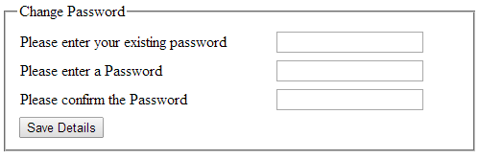

**Note:** This is just a rough guide to required fields and basic layout. It is not intended as a final design

### Screen Fields

|  |  |  |
| --- | --- | --- |
| **Item** | **Type** | **Mandatory** |
| Existing Password | Input – Password  30 CHAR | Y |
| Enter New Password | Input – Password  30 CHAR | Y |
| Confirm New Password | Input – Password  30 CHAR | Y |
| Save Details | Button |  |

## Screen Actions

|  |  |
| --- | --- |
| **Condition** | **Action** |
| * User Clicks on Save Details * Mandatory field is missing | * The message CREATE\_0001 appears as an error with the value ‘$1’ substituted for the missing value. |
| * User Clicks on Save Details * The Enter Password and Confirm Password values do not match. | * The error message CREATE\_0007 appears as an error. |
| * User fills in all mandatory fields. * The Update Password Service returns ‘PASSWORD\_DOES\_NOT\_MATCH’ | * The error message PASSWORD\_0002 appears as an error. |
| * User Clicks on Save Details * The Enter and Confirm Password values match. * If shown, the Terms and Conditions are agreed. | * The user account is activated * The Welcome Email process is started. * The user is redirected to the Login page. |

# Contact Us Form

## Page Access

* This page can be accessed by both logged in owners and non-logged in users

## Navigation to Page

* Shown when the user selects ‘Contact Us’ from the Navigation Options

## Navigation from Page

* A logged in user uses the standard Navigation Options to navigate to another page.

## Screen Wireframes

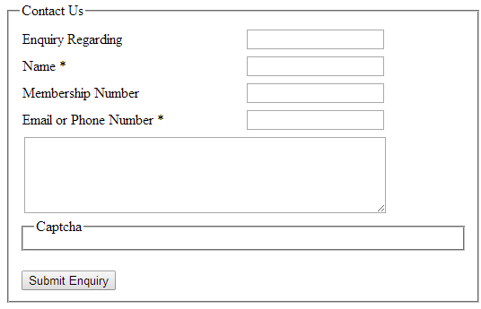

**Note:** This is just a rough guide to required fields and basic layout. It is not intended as a final design

### Screen Fields

|  |  |  |
| --- | --- | --- |
| **Item** | **Type** | **Mandatory** |
| Enquiry Regarding | Drop down  Contains:   * About Privileges by Wyndham * General Enquiry * Membership Enquiry * Forgot Username * Forgot Password | Y |
| Name | Input Field  100 CHAR  Populated with the members first and last name if they are logged in. | Y |
| Privileges Membership Number | Input Field  20 CHAR  Populated with the membership number if user is logged in. | N |
| Email or Phone Number | Input Field  320 CHAR  Populated with the members email address if user is logged in.  Populated with the members mobile number if the user is logged in and there is no email address.  Populated with the members home phone number if the user is logged in and there is no email address or mobile number. | Y |
| Enquiry Text Area | Text Area  1000 CHAR | Y |
| CAPTCHA | Typical web-captcha needed to be entered by a user before the form submits.  Only shown if the user is not logged in | Y  (when Displayed) |
| Submit Enquiry | Button |  |

## Screen Actions

|  |  |
| --- | --- |
| **Condition** | **Action** |
| * User Clicks on Submit Enquiry * Mandatory field is missing | * The message ENQUIRY\_0001 appears as an error with the value ‘$1’ substituted for the missing value. |
| * User Clicks on Submit Enquiry * The user is not logged in * Captcha is incorrect | * The 3rd party Captcha plugin will display an appropriate error message. |
| * User Clicks on Submit Enquiry * All Mandatory fields are filled in | * The message ENQUIRY\_0002 appears as an Information message. |

# System Messages

This is intended as a list of unique error or information messages generated by the system.

|  |  |  |
| --- | --- | --- |
| **Message No.** | **Title** | **Text** |
| UPDATE\_0001 | Required Information is missing | You must enter a $1 to update your membership record. |
| UPDATE\_0002 | Membership Details Updated | Your membership details have been updated. |
| UPDATE\_0003 | Thank You! | Your membership details have been updated in Privileges by Wyndham. Changes will be visible within 72 hours in all other systems. |
| REQUEST\_0001 | Required Information is missing | You must enter a $1 when requesting an additional card. |
| REQUEST\_0002 | Membership limit Reached | You can only have 3 names on a card. |
| REQUEST\_0003 | Additional Card Request | Your additional card request is being processed. |
| REQUEST\_0004 |  | This is a customised message to Owners about the charges they will incur. |
| REQUEST\_0005 |  | This is a customised message to Public, Discovery and Staff Members about the charges they will incur. |
| REQUEST\_0006 |  | This will not update the current postal address on file. If you wish to update your details, please visit your Dashboard <hyperlinked> |
| ENQUIRY\_0001 | Required Information is missing | You must enter a $1 to contact us with a request. |
| ENQUIRY\_0002 | Question Submitted | Your question has been submitted and one of our representatives will be in contact with you. |
| PASSWORD\_0002 | Password does not match | The password you entered does not match the current password we have recorded. |